Working with Children Check
Contents
Who Requires a WWC 1
How to apply WWC workflow 2
Participants Portal – including WWC 2
• Select the state 3
• Add WWC details 3
• Select if your card is Paid/Volunteer 3
• The participant will be asked whether or not they have a current accreditation or exemption with the option to add further details/comments if needed. 4
• A link will also appear directing the registrant to the governing body’s website which will advise them on how to obtain the relevant certification. 4
• PLEASE NOTE. not having a WWCC doesn’t restrict them from finishing the registration 4
• Participants are encouraged to apply for a WWC before process with their Registration 4
Participant WWC detail view 6
Approve Participant 7

Who Requires a WWC
- Participants over the age of 18 years that will be working with children
- Coaches
- Managers
- Referees
- Volunteers

How to apply WWC workflow
Menu: Registration> Signup Form Management> Add New Signup Form > Select non-playing role template
- Registrars will need to create a Signup Form for ‘NON-PLAYING ROLES’
- Apply your sign-up form to your Registration Product I.e. Coach/Manager registration Product
- ‘REQUIRES WORKING WITH CHILDREN WORKFLOW’ - needs to be ‘ticked’ to enable WWC requirements to the non-playing registration process

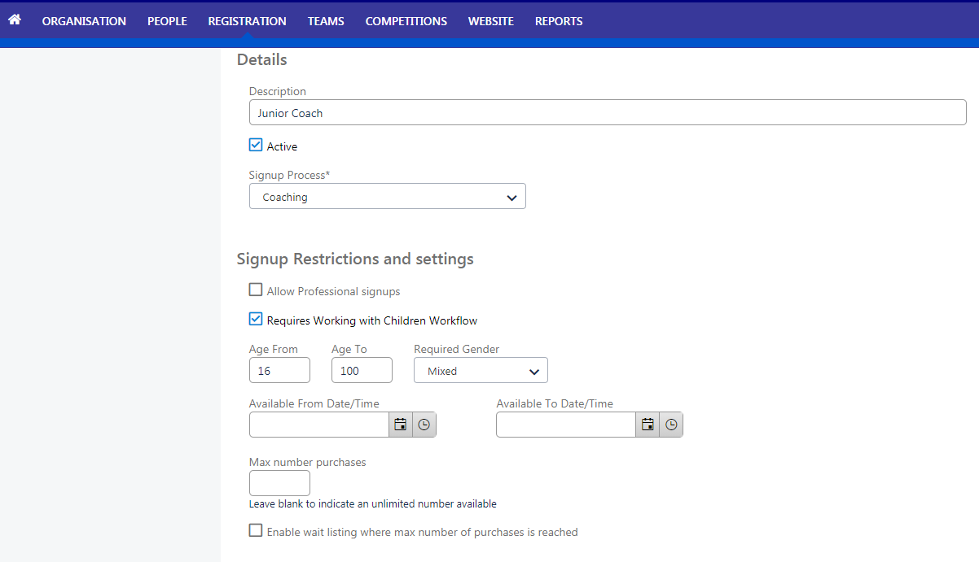

Participants Portal – including WWC
- Participants registering as non-players will need to create a ‘Football Account’
- Football Accounts can be created here >>>> https://www.ffa.com.au/football-account
- The registration for both Players & non-Players are identical however non-players are prompted to answer WWC questions (see Below)

PLEASE NOTE: This is simply capturing the participants information. It DOES NOT automatically validate the participants details. A manual validation for Participants is required

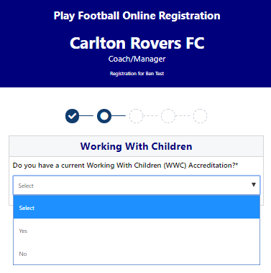

Working with Children – if YES was selected, they are then required to:
- Select the state
- Add WWC details
- Select if your card is Paid/Volunteer

NOTE: If you are UNSURE if you require a paid or volunteer WWC please speak with your Member Federation/Association Directly.

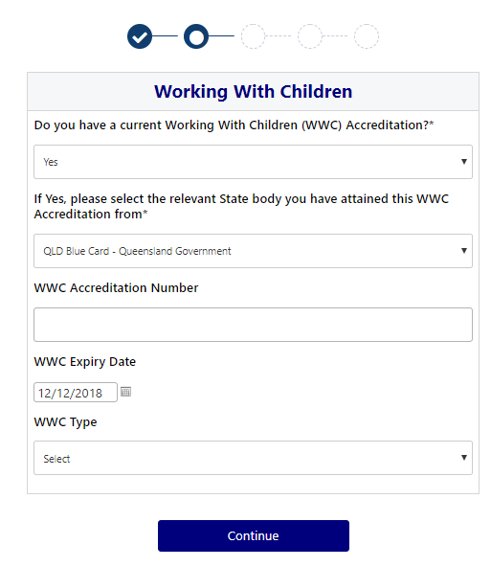
Working with Children – if NO was selected
- The participant will be asked whether or not they have a current accreditation or exemption with the option to add further details/comments if needed.
- A link will also appear directing the registrant to the governing body’s website which will advise them on how to obtain the relevant certification.
- PLEASE NOTE. not having a WWCC doesn’t restrict them from finishing the registration
- Participants are encouraged to apply for a WWC before process with their Registration
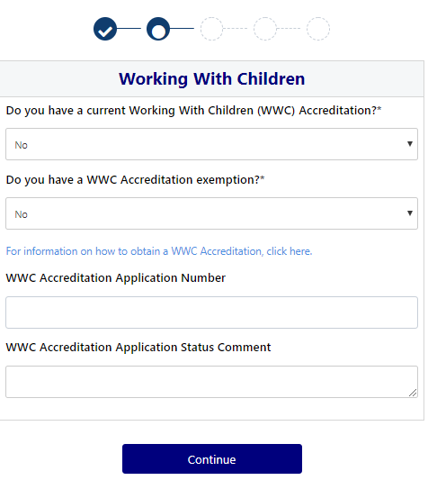

- Once a Participants submits their registration, Club registrars will be able to manage their registration
Menu: Registration > Registration Management > Filter > Registration Status – Requires Clearance

- Select ‘eye’ icon to view Participants WWC information

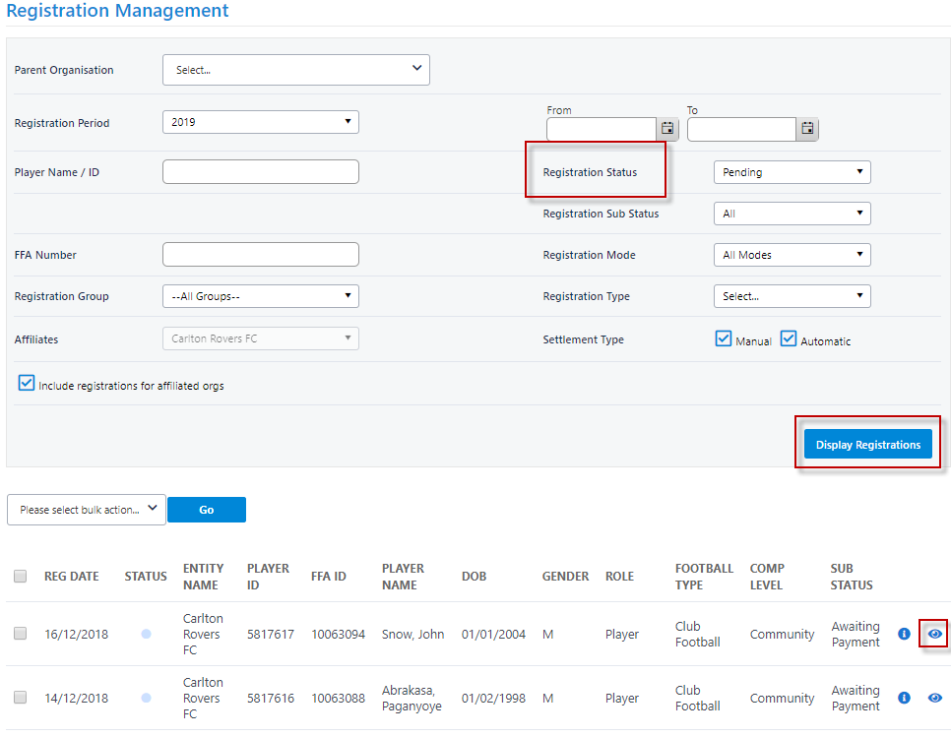

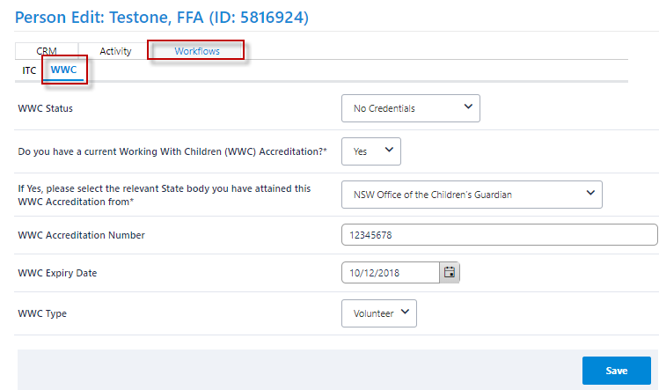
Participant WWC detail view

- Once you have ‘Manually’ checked the participants WWC against the correct government Data base
- ‘Manually’ change the Participants status accordingly

Approve Participant

